**Winding**

You will be winding the motor using a three phase Y-configuration as shown in the image below. Note the image below shows the series winding fashion for this configuration, parallel winding is also a viable option and will be explained as well.

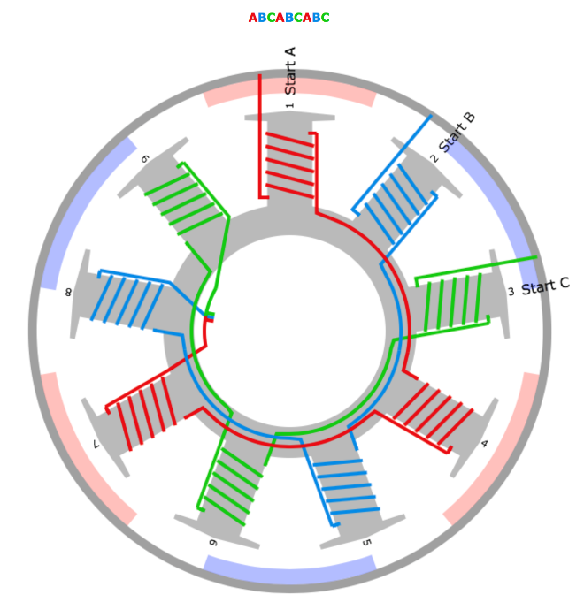

**Figure 1: Three Phase Y-Configuration Winding scheme**

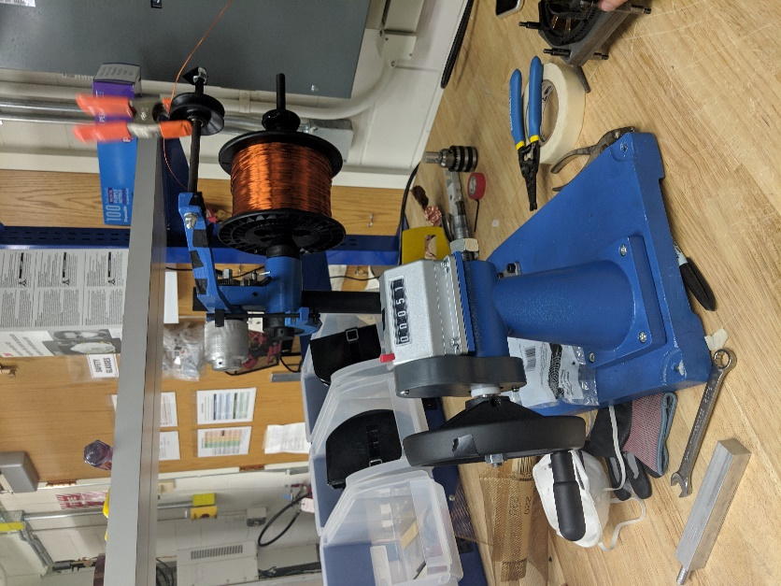 If you choose to wind in series you may wind one tooth at a time, this will require soldering post winding to form the series configuration, or you may wind three teeth at a time which will take more time per winding session, but only require the use of three copper wires. Winding only one tooth at a time requires more wire joining and organization after you finish winding but is less complicated. Choose a wire gauge based on current density (~8 A/mm2 recommended), slot area and fill factor (~0.4 for random wound) and number of turns. Grab your stator assembly and the wire gauge you will wind with now as well as some type of counter (a cellphone app will work if preferred to the counters in lab). All winding will be done counterclockwise, you may want to mark the top of your stator to ensure you are winding from a top down view and staying consistent with the wind direction. Setup up the spool with your copper wire as shown in the image to the right. Next, put on a lightly insulated work glove on your preferred wiring hand, this will make pulling the wire tight much easier. Pull some wire now and make a counter-clockwise loop in your hand with about six inches of free wire. Place this loop around the tooth you will be winding first, pull the wire tightly in opposite directions to ensure you begin winding with a strong alignment.

Make two or three more loops, checking the wire alignment on both sides, until you can pull on the wire from the spool without disturbing the free wire from the first loop.

Now increment your counter to account for the first three or four turns, depending how many you made to ensure the free wire does not move when pulling the wire end still being fed from the spool. Make a half counterclockwise turn, turn over your stator, check the wire alignment on the bottom and pull it tight, make another half counterclockwise turn, check the wire alignment on the top of your stator and pull it tight. One full turn will be completed and you may increment you counter by one. This process will be repeated until you have wound a solid layer across the whole tooth surface, then, maintaining counter clockwise winds, you will wind back towards the direction of the first loop. The image below shows a completed first layer of winding and this is the alignment you should aim for on both sides of the stator tooth. The more aligned you can wire the tooth, the easier it will be to achieve your fill factor.

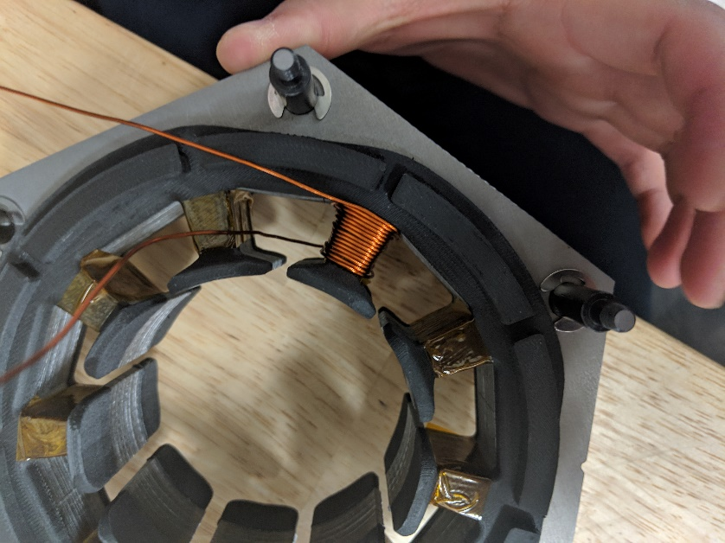

If you find you are having issues maintaining alignment as you turn your stator over to pull the wire from the other side, it helps to keep your non wiring hand on top of the wire as you make your turns. The image at the top of the next page shows this method for clarity.

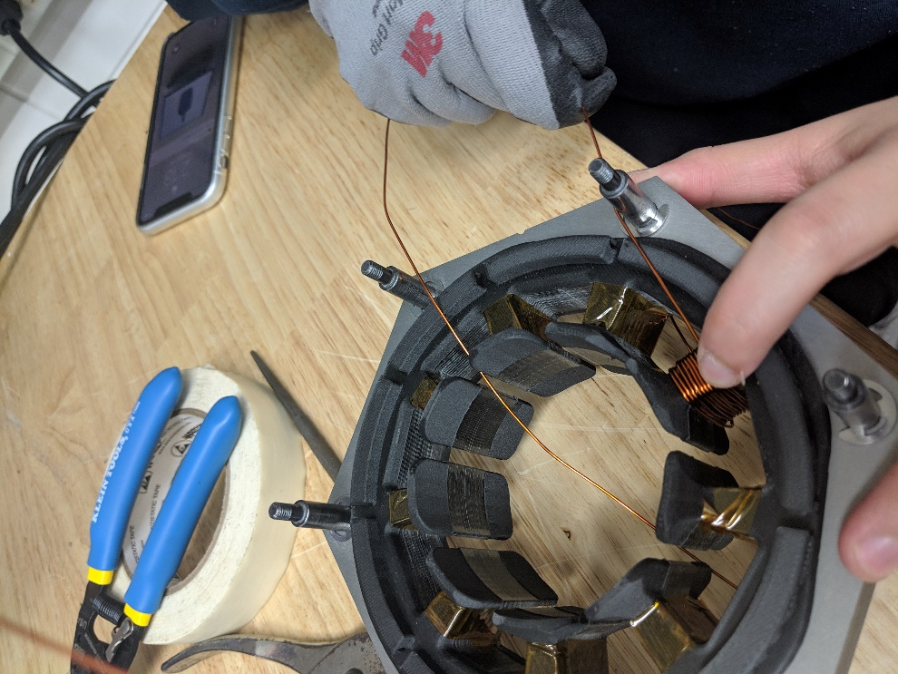

After finishing a tooth, if you are winding in parallel or if you plan to solder your wires in a series configuration after winding all teeth you may cut the wire from the spool leaving about six inches again and start the process over on the next tooth. The image below shows a completed tooth, notice the wire alignment has been maintained since winding the first layer.

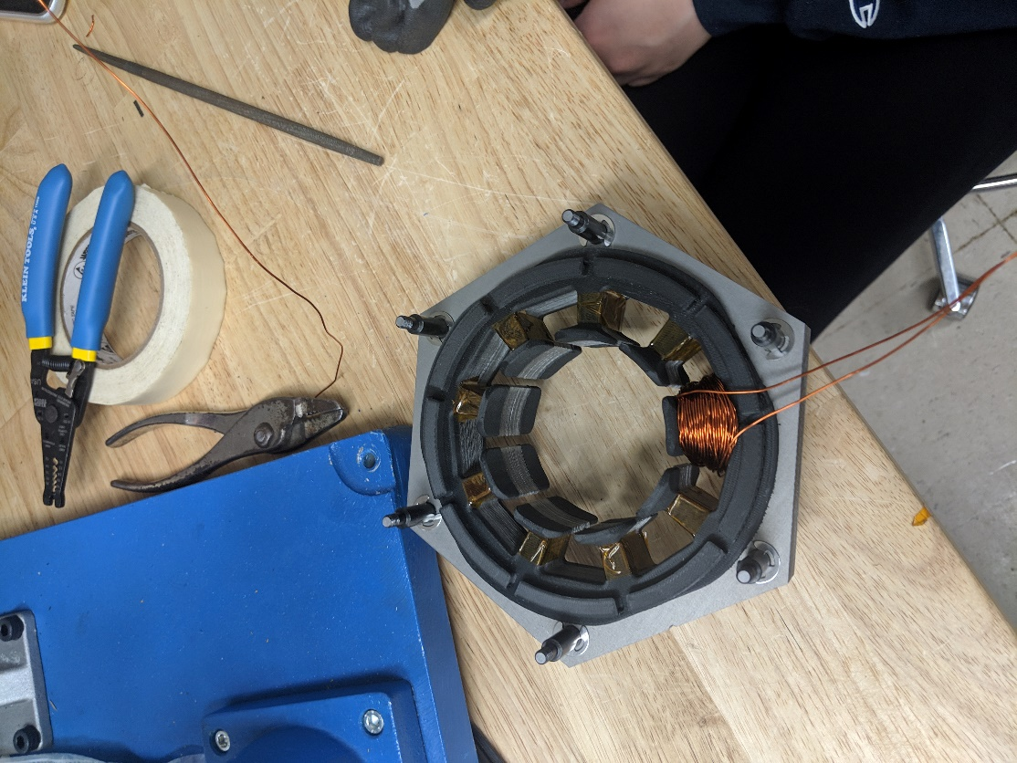

If you would like to wind in series without soldering, then without cutting the wire from the spool, feed the wire to next tooth which is three teeth away, refer to the three phase y configuration diagram and follow the red wire to clarify the series wind. The image at the top of the next page also shows feeding the wire to the next tooth to be wound for clarity.

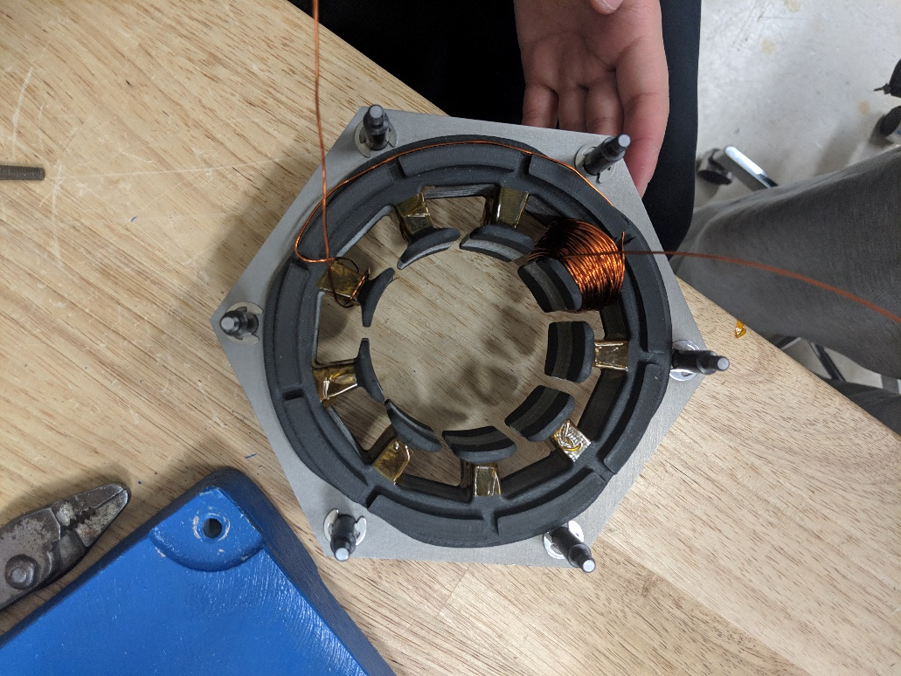

Note if you choose this method, you will wind three teeth before cutting the wire from the spool, the free wire end is still affixed in the first tooth as shown in the image above and will make the first few turns on the second and third tooth a little easier, but you will need to finish all three teeth in a phase in one sitting.

After all teeth have been wound it is now time to join the coils. To connect the coils in start by removing the enamel insulation from the wires. The amber 200C insulation must be sanded off however, the red Solderon 155C red insulation acts as flux and doesn’t need to be removed. When all wires have been stripped you are ready to join them to form the neutral point, phase A, phase B, and phase C configurations.

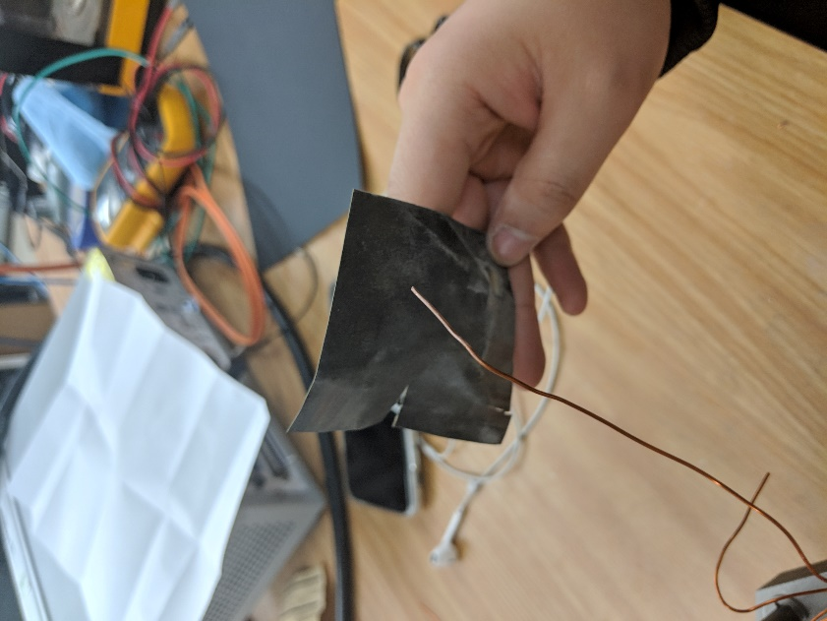

Now beginning with one tooth, grab the right wire, and grab the right wire from the tooth which is three teeth away and six teeth away. Refer to the three phase y configuration diagram for clarity, from top down perspective, tooth 1, 4, and 7 will be joined in series for phase A, tooth 2, 5, and 8 will be joined for phase B, and tooth 3, 6, and 9 will be joined to form phase C. Verify positive current creates flux in the same direction for all teeth.

Next, grab the three free wires on the right side of their respective teeth. If your winding scheme matches the three phase y configuration exactly, these will be the wires on tooth 7, 8, and 9. Twist these wires together as shown in the image below to form you motor neutral point and solder these wires for a more permanent joining and better connection.

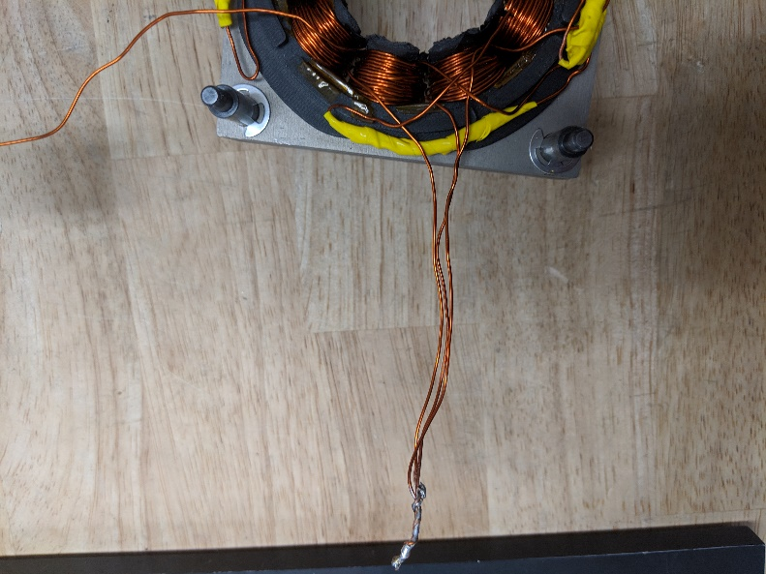

Now move your neutral point off to the side of your motor, organize the other free wires similar to the image at the top of the next page, you are now are ready to move on in the fabrication process to the testing of your motor. Note extra wire as been soldered to each phase lead, this may be necessary for your motor depending how long you left your wires after winding each phase.

